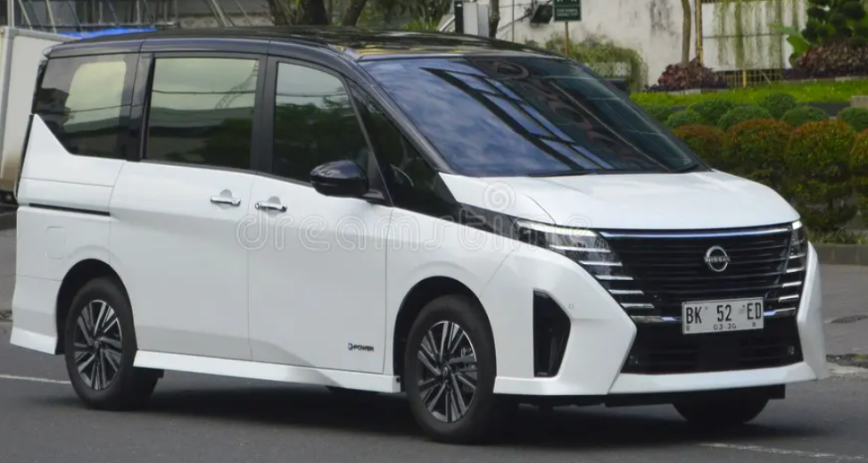

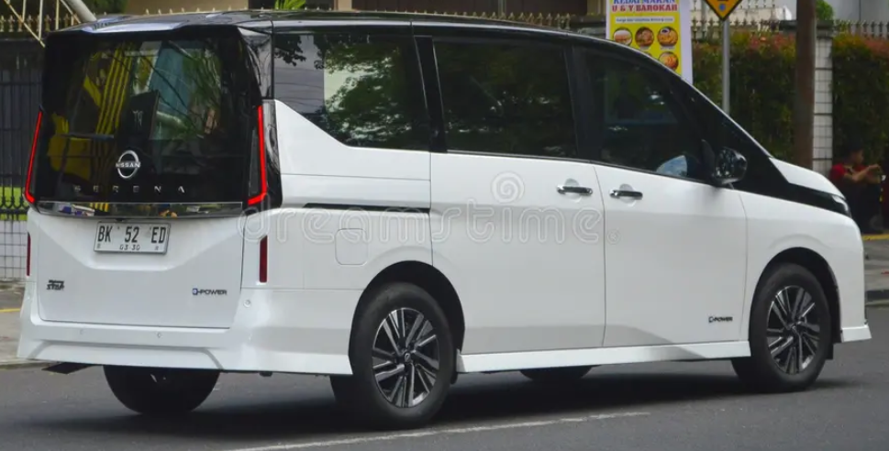

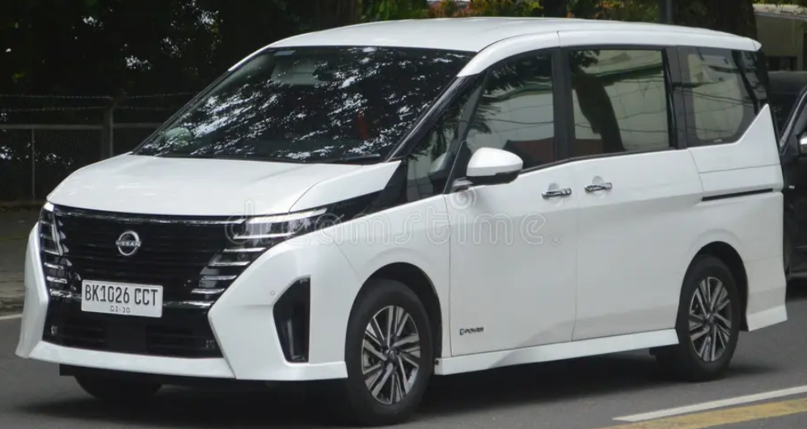

Main Specification of Honda Odyssey

**🚗 Powertrain & Performance**

## 🚗 Powertrain & Performance

* **Hybrid System**: e‑POWER (1.2 L 3‑cyl petrol engine + electric motor) or mild S‑Hybrid/2.0 L petrol depending on market
* **Combined Output (for e‑POWER)**: ~160 bhp (≈163 PS) with ~250 Nm torque
* **Gasoline-Only Option (MR20DD 2.0 L)**: ~148 hp @ 6,000 rpm and 200 Nm @ 4,400 rpm
* **Transmission**:
  + e‑POWER: single-speed automatic
  + Petrol: CVT

**📏 Dimensions & Capacities**

* **Length × Width × Height**: ~4,770 × 1,740 × 1,865 mm
* **Wheelbase**: ~2,860–2,870 mm
* **Ground Clearance**: ~140–160 mm
* **Kerb Weight**: ~1,700–1,900 kg (varies by spec/market)

**🛋️ Seating & Cargo**

* **Seating Capacity**: 7 (some markets also offer 8-seater layout)
* **Boot Space**: ~210–280 L behind 3rd row (varies by configuration)

**🔧 Chassis & Running Gear**

* **Suspension**: MacPherson front struts; rear torsion beam
* **Brakes**: Ventilated front discs, solid rear discs
* **Wheels & Tyres**: 16″ alloy wheels with 195/60–65 R16 tyres

**⛽ Fuel & Efficiency**

* **Fuel Tank**: ~55–60 L
* **Fuel Economy**:
  + e‑POWER hybrid: ~15–18 km/L (India); WLTC ~19.3 km/L (Hong Kong)
  + Petrol: City ~16 km/L, Highway ~11 km/L (Pakistan figures)
* **Top Speed**: ~180 km/h

**🛠️ Steering & Safety**

* **Steering**: Electric rack‑and‑pinion with turning radius ~5.5–5.7 m
* **Safety Features**:
  + e‑POWER variants include Around‑View Monitor, collision prevention, lane departure, blind‑spot alerts, multiple airbags
  + Petrol versions offer ABS, EBD, parking sensors

**✅ Summary**

The Nissan Serena is a spacious hybrid MPV optimized for family use, offering a smooth single-speed e‑POWER system or a conventional petrol CVT. It’s well-equipped with safety tech, sliding doors, and versatile 7‑seat layouts. Fuel economy ranges from ≈15 km/L (WLTC) up to ~18 km/L depending on the trim and market.